
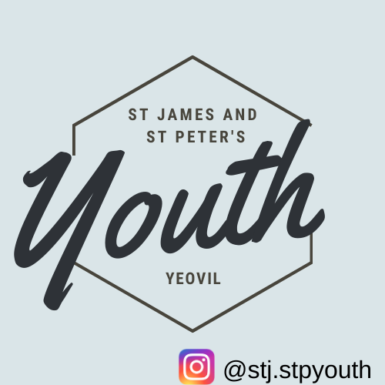
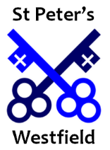
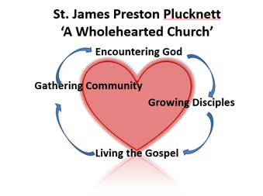
Consent form and Medical Form
It is important that we have up to date details on your child for when they are in our care. Please fill out the information below as fully as possible for our records. Please also read through and sign at the end.
Name of Child
D.O.B.
Address
Postcode
Home Tel
Name of parents/adults with parental responsibility for child
Work Number
Mobile Number
Email
Doctor
Heath issues, medical conditions, allergies etc
Permission for using plasters
School
Anything else we need to know to enable us to fully support your child?

YES/NO
I give permission for my child’s photograph to be taken during activities at St James and St Peters?
May we use your child’s photograph in the parish magazines? YES/NO
May we use your child’s photograph on the parish website? YES/NO
May we use videos of your child on Tick Tock and Instagram? YES/NO
May we contact your child through a What’s App/Instagram group? YES/NO

I give permission for the child listed above to take part in the normal activities of children’s and youth activities at St James and St Peters. I understand that the leaders will take all reasonable care in looking after my child but the leaders cannot necessarily be held responsible for any loss, damage or injury suffered at the group.

In an emergency, if I cannot be contacted despite all reasonable attempts to do so by the leaders, I give permission for my child to undergo emergency medical/dental treatment including the use of anaesthetics/blood transfusions as considered necessary by the medical authorities.

If you are happy for your child to walk home on their own, please indicate below, otherwise we will keep them with us until someone arrives to collect them. YES/NO
P.T.O
I confirm that these details are correct to the best of my knowledge.

Signature of child/young person (if over 11 years old):
Print name child/young person:
Date:
Signature of parent / carer:
Print name parent / carer:
Date:

